1. **Command**🡺Update() vs updateMany()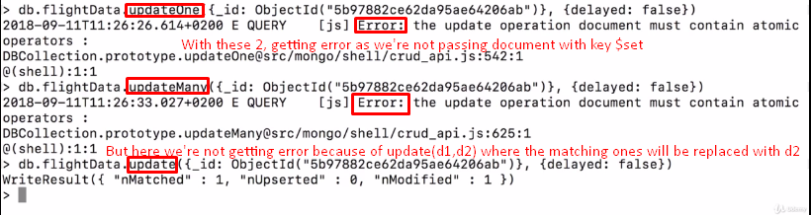
2. **Command**🡺replaceOne()